logo_db_sch_DINA4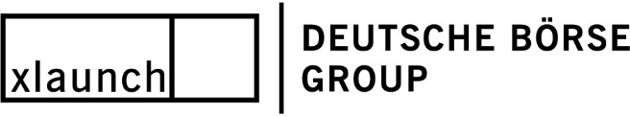

|  |  |
| --- | --- |
| **Process document** | |
|  | |
|  | **Enterprise Architecture Repository (MEGA)** |
|  | Internal Use Only |











**Contents**

[1 General information 6](#_Toc525121580)

[1.1 Change History 6](#_Toc525121581)

[1.2 Document version management 6](#_Toc525121582)

[1.3 Related documents 6](#_Toc525121583)

[2 Introduction 7](#_Toc525121584)

[2.1 Background 7](#_Toc525121585)

[2.2 Scope of the document 8](#_Toc525121586)

[2.3 Out of scope 8](#_Toc525121587)

[3 Risks , Interfaces, SLA/OLA 8](#_Toc525121588)

[3.1 Risks 8](#_Toc525121589)

[3.2 Interfaces 8](#_Toc525121590)

[3.3 SLA/OLA 9](#_Toc525121591)

[4 Overview of roles & responsibilities and processes 10](#_Toc525121592)

[4.1 Major Stakeholders 10](#_Toc525121593)

[4.2 General roles & responsibilities 12](#_Toc525121594)

[4.3 Overview of processes 15](#_Toc525121595)

[4.3.1 Add an application 15](#_Toc525121596)

[4.3.2 Delete an application (Current process) 20](#_Toc525121597)

[4.3.2.1 JIRA workflow details (future process) 21](#_Toc525121598)

[4.3.2.2 Process steps of the approval process 24](#_Toc525121599)

[4.3.3 Maintenance of data (“mandatory fields”) 24](#_Toc525121600)

[4.3.4 Ensure data quality of applications in MEGA 28](#_Toc525121601)

[5 Annex 31](#_Toc525121602)

[5.1 General definition of applications and technologies in Deutsche Boerse Group 31](#_Toc525121603)

[5.2 Overview of banking regulated Legal Entities 33](#_Toc525121604)

[5.3 Quick Guide on “how to view changes of application data” 33](#_Toc525121605)

[5.4 Clearing Modelling Guide 34](#_Toc525121606)

[Figure 1: Screenshot of comprehensive overview – core SW & HW inventories & processes (as of 14.09.2018) 7](#_Toc525219237)

[Figure 2: MEGA product contacts as of 29.08.2018 9](#_Toc525219238)

[Figure 3: Roles&responsibilities overview (as of 21.08.2018) 10](#_Toc525219239)

[Figure 4: Overview of processes (as of 28.06.2018) 11](#_Toc525219240)

[Figure 5: Status overview and description on data completeness in MEGA 12](#_Toc525219241)

[Figure 6 : 13](#_Toc525219242)

[Figure 7: snapshot ITSR (as of 02.01.2018) 14](#_Toc525219243)

[Figure 8](#_Toc525219244)**[:](#_Toc525219244)** [Delete process overview 16](#_Toc525219244)

[Figure 9: overview of mandatory fields (as of 25.02.2018) 18](#_Toc525219245)

[Figure 10: Maintenance process overview 20](#_Toc525219246)

[Figure 11](#_Toc525219247)**[:](#_Toc525219247)** [Review and contorl process overview 22](#_Toc525219247)

[Figure 12](#_Toc525219248)**[:](#_Toc525219248)** [definition of an application within MEGA (as of 25.02.2018) 23](#_Toc525219248)

[Figure 13: see ClearingModelling Guide slide no 24](#_Toc525219249)

[Figure 14: Screenshot of application history in the MEGA GUI 26](#_Toc525219250)

[Figure 15: Clearing Modelling Guide (as of 2017) 26](#_Toc525219251)

# General information

## Change History

|  |  |  |  |
| --- | --- | --- | --- |
| Version | Date | Author | Change reason |
| 1.0 | 2017/08/22 | Arne Rosin / Nicole Fich | Initial version |
| 1.0 | 2017/12/11 | Nicole Fich | Input of Mario Quonils |
| 1.1 | 2018/02/15 | Nicole Fich | Update roles&responsibilities, MEGA contacts |
| 1.2 | 2018/08/01 | Nicole Fich | Update on processes |

## Document version management

The document is owned by Corporate Systems and will be reviewed on a yearly basis.

## Related documents

|  |  |  |
| --- | --- | --- |
| No | Title | Location |
| 1 | Enterprise Architecture Repository (MEGA) Process | [Intranet: Guidelines/IT/Guidelines IT/IT Process Descriptions](http://intranet.deutsche-boerse.de/INTRANET/departments/ci_tqm.nsf/WebDocuments/BE96524AC06A3301C1257E220035114B) |
| 2 | Clearing Modelling Guide | See document in annex |
| 3 | Information Owner | http://intranet.deutsche-boerse.de/INTRANET/departments/gis.nsf/0/5F585F612681D0F6C12576CE00537FA0/ $file/Information%20Owners%20201706.pdf |

**Abreviations table**

|  |  |
| --- | --- |
| **LE** | **Legal Entity** |
| **IO** | **Information Owner** |
| **BO** | **Business Owner** |
| **CBF** | **Clearstream Banking Frankfurt AG** |
| **ECAG** | **Eurex Clearing AG** |
| **MEGA** | **Enterprise Architecture Repository** |
| **CBL** | **Clearstream Banking Luxembourg S.A.** |
| **GIS** | **Group Information Security** |

# Introduction

## Background

Enterprise Architecture Repository of DBAG is dubbed EA Tool or MEGA. The purpose of MEGA is to document existing functional, application and technology architecture and maintain it on high level.

Now it is used as an IT Software Inventory to track IT assets (e.g. business applications) on a detailed level like software installation version, interfaces, etc..

MEGA provides group-wide visibility into current DBG IT landscape (excl. Local Applications), supports impact analysis for new projects and initiatives, used as basis for risk assessments on GIS side, information source of application for the iBase (mapping application to servers) and identifies opportunities for consolidations, improvements and re-use.

MEGA runs on the product ITPM (Information Technology Portfolio Managment) provided by the company [www.mega.com](http://www.mega.com). Provision is by access via web browser and a GUI based on MEGA proprietary "HOPEX" technology. Data is stored in an Oracle database and on the Application Server.   
The central entity is an application with its components, used technology, interfaces to other applications and data flows. However, MEGA also holds information on Legal Entities (owning, using), Product Lines and responsibilities (Information owner, IT application owner, Business owner).

## Scope of the document

This document names the major stakeholder and defines the main roles & responsibilities of application objects in MEGA as well as the maintenance of data to assure proper and complete information. Furthermore, the processes to add and delete applications are described as well as the implemented control processes.

## Out of scope

The definitions of each field in MEGA are not described in this document in detail. These definitions are documented in the Clearing Modelling Approach (see annex). Furthermore, the details regarding how to add an application etc. are described in the User Manual and Training material.

# Risks , Interfaces, SLA/OLA

## Risks

There could be some operational risks like:

* Server is down
* Log-in of User failed
* Error by updating system
* Maintenance of data – deletion of data, incorrect information, etc.

## Interfaces

There are two existing interfaces at the moment:

1. Daily export of data (as csv.file) to CMS (iBase).
2. Import of User data (ID, name, email address) to MEGA from LDAP Server for Log-in purposes.

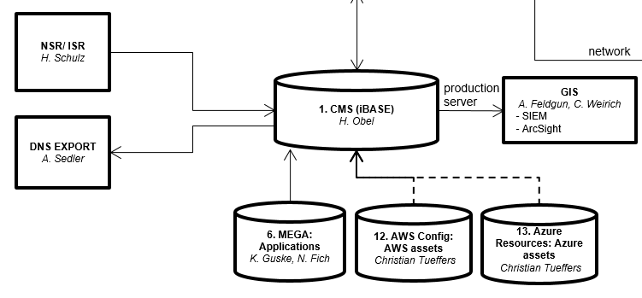

Figure 1: Screenshot of comprehensive overview – core SW & HW inventories & processes (as of 14.09.2018)

## SLA/OLA

There are currently no SLA/OLA between the Products and MEGA application owner Corporate Systems as well as Legal Entities.

# Overview of roles & responsibilities

The main roles and responsibilities in MEGA are described in this chapter.

## Major Stakeholders

The Enterprise Architecture Repository of DBAG (MEGA) is used by the following parties:

* Product management of 15 products[[1]](#footnote-1) represented by Product Co-Leads (Technology, Business) (see figure 3 below)
* Group Information Security (IS Governance & Risk)
* Legal Entities[[2]](#footnote-2): focus on banking-regulated ECAG, CBF, CBL represented by CTOs or deputies
* Corporate Systems as operating the Application MEGA
* IT Infrastructure
* Information Owner (see <http://intranet.deutsche-boerse.de/INTRANET/departments/gis.nsf/0/5F585F612681D0F6C12576CE00537FA0/$file/Information%20Owners%20201706.pdf>)

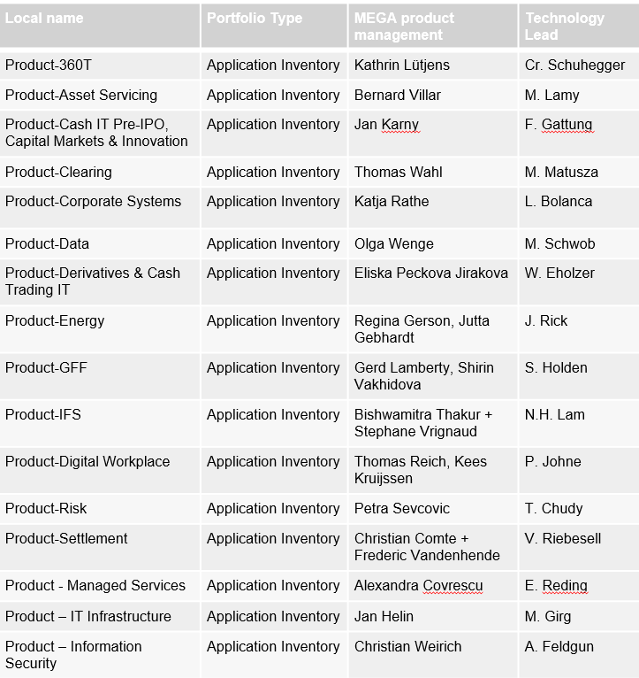

Figure 2: MEGA product contacts as of 29.08.2018

## General roles & responsibilities

The 15 Products[[3]](#footnote-3) execute defined processes (add, delete, maintain – excl. risk attributes). They are responsible for the ongoing maintenance of data (excl. risk attributes) in the software inventory (MEGA) and the right content of the application within the portfolio.

Group Information Security (GIS) maintains security relevant attributes (Max Confidentiality, Max Integrity, Max Availability, Max Authenticity, Max Criticality) and the Information Owner. The Software inventory is used as a trigger for risk assessment.

The Legal Entities (LE) are accountable for the content provided in MEGA. Each Legal Entity assigned to an application as “Using Legal Entity” has to check all applications and its data. Furthermore, they have to validate the adds on relevance and confirm deletions that is triggered by product MEGA contact. The Legal Entities maintain the Using and Owning Legal Entity field.

IT Infrastructure consolidate data from software inventory and new CMDB. They use the MEGA application data especially MEGA AID and security classification to map the servers to it.

Corporate Systems (CS) is the Application Owner of the software inventory (MEGA). CS runs/maintains the software inventory and is doing the License Management. Moreover, CS finally delete/ decommissioning the application if confirmed by legal entity. CS provides Training Sessions for users.

The Information Owners (IO) receive regular information regarding all new added or deleted applications as well as security attributes of his/her applications. Furthermore, IO determines the security attributes used by his/her using Legal Entity.

For further details on roles&rights please refer to the Authorization Concept.

(see figure below) Each role can be requested via ITSR.

|  |  |  |  |  |
| --- | --- | --- | --- | --- |
| **Roles in MEGA** | **Permissions** | | **Group of Users within DBG** | **Task** |
|  | *Read* | *Write* |  |  |
| DBG Application Owner | Read access to all applications | Write access to own application (responsibility = contributor) | IT Contributor | * Modify all application’s relevant data |
| DBG Application Portfolio Manager | Read access to all applications | Restricted read and edit rights on portfolio and application data belonging to ones own product / portfolio. No write access for security attributes. Assign any application to the own product | Nominated contact person in each product | * Set up new applications and assign at least an IT contributor to it. * Check data quality of all applications regularly |
| DBG Information Security Officer | Read access to all applications | Maintain/enter overall (currently only one set for all entities) security attributes. | Group Information Security | * Maintain risk relevant attributes (Max Confidentiality, Max Integrity, Max Availability, Max Authenticity, Max Criticality) and Information Owner * Software inventory as a trigger for risk assessment |
| DBG Customizer | Read access to all applications | Maintain functional static data | Corporate Systems | * Maintain list of technologies, vendors, sites, references, City plan, Legal entities, Org-Units, Contents |
| DBG Legal Entity Responsible | Read access to all applications | Write access to all applications to add / remove a legal entity as “owning” or “using legal entity”. | Legal Entity contact person | * Maintain owning and using legal entity entries. Use compliance reporting to ensure data quality. |

Figure 3: Roles&responsibilities overview (as of 21.08.2018)

Moreover a

panel, that is presented by the major stakeholders (banking-regulated LE, IT Infrastructure, GIS, CS), will be called if there is need for discussion, e.g. not all LE have approved the deletion of an application. It is used as an escalation body.

# Overview of processes

In the following the main processes (add, decommissioning, maintain) are described.

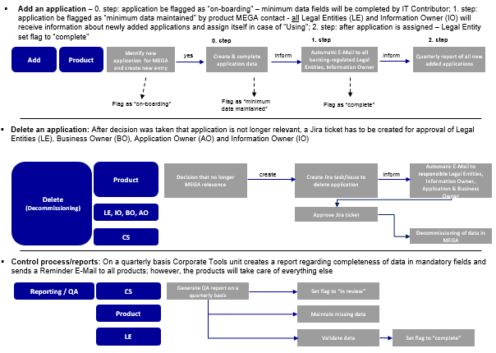

Figure 4: Overview of processes (as of 28.06.2018)

## Add an application

Add an application is seprated in several process steps:

1. The employee of a product who is nominated to maintain the application[[4]](#footnote-6) data in MEGA is the Product MEGA contact (role in MEGA: DBG Application Portfolio Manager). He/she sets up a new application and assigns at least an IT contributor (role in MEGA: DBG Application Manager) to it.
2. Then the Product MEGA contact has to flag (see figure below) the application regarding its status of data within MEGA. If the application is newly added and information will be filled the status is “on-boarding” (e.g. project mode or handover to another department).
3. Data fields will be completed by IT Contributor and Product MEGA contact.
4. After completing the minimum set of data by the Product MEGA contact and IT Contributor the status has to be changed to “minimum maintained data” by the Product MEGA contact after he/she validates data fields.
5. Then an automatic Email[[5]](#footnote-7) to inform all banking-regulated[[6]](#footnote-8) Legal Entities (LE) and Information Owner (IO)[[7]](#footnote-9) about newly added applications will be generated.  
   (Email draft see annex 6.3)
6. If the application belongs to the portfolio, the Legal Entity responsible has to assign the Legal Entity as Using or/and Owning Legal Entity and set the status to “complete”.
7. .Finally,
   1. A quarterly “completeness report” will be sent to all Product MEGA contacts to fill in the missing data and check data regarding correctness.
   2. A quarterly “compliance report” will be sent to all banking-regulated Legal Entitites including the list of applications assigned to their Legal Entity. The Legal Entities have to check and confirm the current status.
   3. A quarterly report of all new added applications and Using/Owning Legal Entities as well as completeness of data will be sent for information to all banking-regulated Legal Entities.
   4. further details see chapter 3.3.4

|  |  |
| --- | --- |
| **Status** | **Description** |
| “onboarding” | If the application is newly added and information will be filled,. e.g. project mode or handover to another department. |
| “minimum maintained data” | Application name, short/long description, IT Contributor be filled |
| “complete” | All 13 mandatory fields are filled. |
| “In review” | Quarterly review of data |
| “retired” | ITSR “delete application”[[8]](#footnote-12) is submitted. |

Figure 5: Status overview and description on data completeness in MEGA

**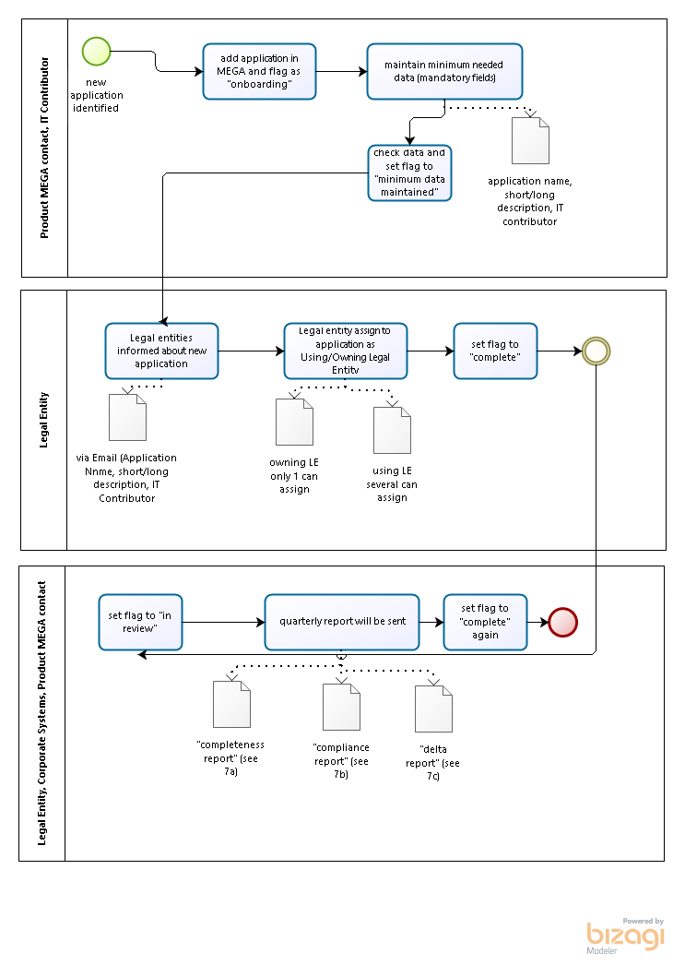**

Figure 6 : Add process including flag - workflow status (21.08.2018)

Furthermore, if the 13 mandatory fields are filled the status will be set to “complete” by the Legal Entity. Quarterly a review of the data regarding completeness and correctness are done by the product MEGA contacts, here the status is set to “in review”.

When an application will be decommissioned (see chapter 3.3.2) the status will be set to “retired”.

## Delete an application (Current process)

A deletion of applications and components has been disabled for all users in MEGA and instead an IT-Service request (ITSR) has to be raised in Lotus Notes. The approvers of the ITSR are manually chosen by the MEGA administrators who have to look up the IT application owner and the business owner in MEGA. The using legal entities are currently not involved as approvers of the ITSR.

IT Service Request – Form/Formular – 05. Access Authorisation – EA Tool (MEGA) delete application (as of 02.01.2018)

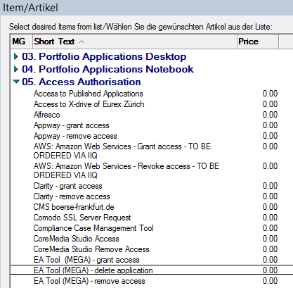

Figure 7: snapshot ITSR (as of 02.01.2018)

After approval of the ITSR the technical admin of MEGA is decommissioning the application.

End of 2018 the delete process will be managed via a Jira workflow.

### JIRA workflow details (future process)

* Implement delete buttons on application and on component level that are active for all users having write access to the application / component.
* Trigger an approval workflow in JIRA via a RestFul API.
* Starting point for the workflow in JIRA should be an automated E-Mail for the initiator of the deletion. He should accept the ownership of the process, give reasons, i.e. a comment why the item is to be deleted and he should be able to delegate the ownership of process to someone else. Doing the latter, he should still be able to see the status of the workflow.
* The creator / owner of the “Approval” process may at any given time change the status to “Approval rejected” when he comes to the conclusion that an application or component should not be deleted.
* In case of multiple people listed as IT application owner, business owner or legal entity representatives an approval sub-task should be created for all these people but when one of each group has approved the deletion than no further approval is required from the others of the same group. An E-Mail should be sent to those ones that are no longer required for approval.
* Enable the requestor of a deletion process in getting an overview of the approval status.
* Inform MEGA administrators of completed approval process to have them delete / decommission the application / component.
* Enable the requestor of a deletion to remind all outstanding approvals automatically via E-Mail.

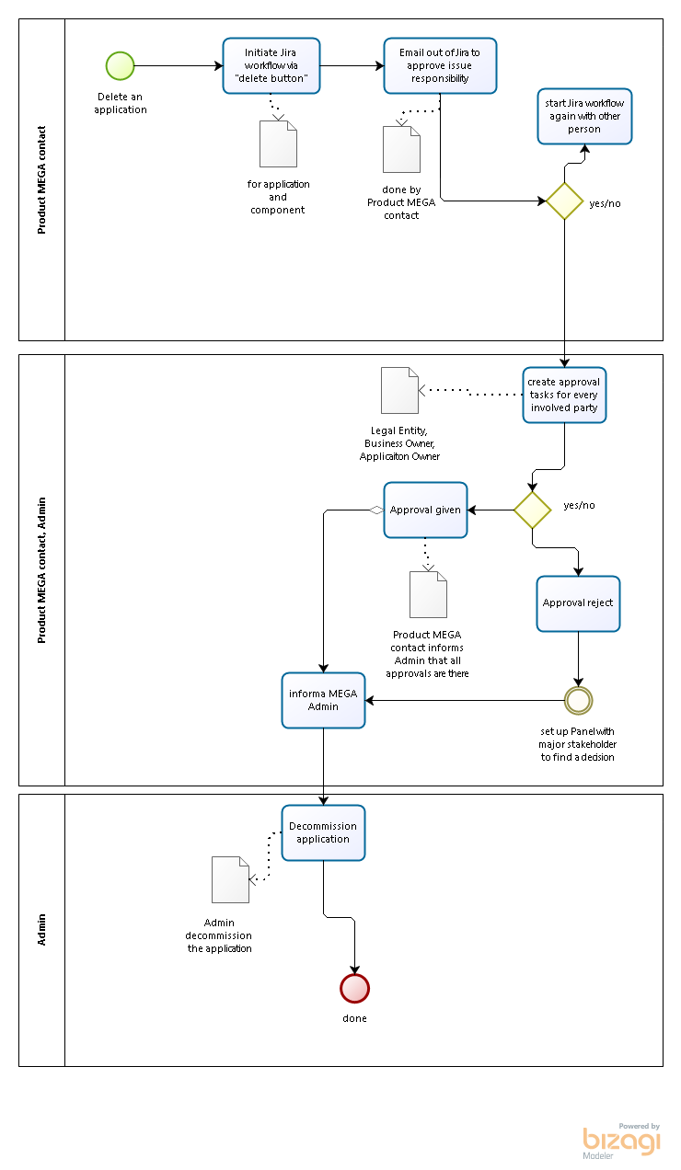

Figure 8**:** Delete process overview

### Process steps of the approval process

* On Status “Approval New” the owner of the process can delete all but one “Sub-Approval” task for an area or create a new one for an area. As soon as he/she sets the “Approval Status” to “Approval in Progress” as many Emails as sub-tasks exist have to be sent out to the approvers (status “Sub-Approval New”)
* Each approver receiving a link to his/her “Sub-Approval” task may accept, reject or delegate his/her approval.
  + On “accept” status change to “Sub-Approval given”
    - Set status of object “Approval” to status “Approval in progress”
    - All other Sub-Approvals for the same area (i.e. IT Application Owner, Business Owner or the same Using Legal Entity) will be set to status “Sub-Approval not required”) and an E-mail has to be sent to those ones who’s approval is no longer required.
  + On “reject” status change to “Sub-Approval rejected”
    - Set status of object “Approval” to status “Approval in progress”
    - An E-Mail will be sent to the owner of the process informing him that the approval was rejected.
  + On “delegate” status remains “Sub-Approval New” but:
    - E-Mail with link to “Sub-Approval” will be sent to delegate. Restart process
    - If all approvals have been given the status of the “Approval” object will get the status “Approval given”.
    - An E-Mail will be sent to the owner of the process to inform him about the complete approval
    - An E-Mail will be sent to the MEGA administrators to inform them that the application / component can now be deleted / decommissioned.

## Maintenance of data (“mandatory fields”)

The Legal Entities Clearstream Banking Frankfurt AG (CBF) and Eurex Clearing AG (ECAG), IT Infrastructure as well as Group Security aligned on information they need out of MEGA for audit reasons, so called “mandatory fields” (see figure below) that have to be maintained by the products. Therefore, the product leads nominated employees for their product (=Product MEGA contact). Ensuring that the data is complete and up to date a quarterly report is sent to all product conctacts. (details see chapter 3.3.4)

|  |  |  |
| --- | --- | --- |
| **#** | **Fields** | **Description** |
| 1 | Application Code / ID (automatically generated) | The application ID is a unique identifier for an application which should be immutable over its lifetime |
| 2 | Description (short and long) | Summary of the application outlining its purpose and other information that is not covered by other fields |
| 3 | Contributor (responsible for data maintenance) | Assigning the Contributor role provides write access to an application to a person in MEGA. Receives messages to maintain application data |
| 4 | IT Application Owner | Person who is accountable for accuracy of the application description in MEGA |
| 5 | Business Owner | Person who is primarily accountable for the business supported by an application |
| 6 | Technology | List of technologies used by the application/ component. Technology is defined in a broad sense to address all logical and physical assets underpinning the implementation or execution of an application. This may include vendor or open source products, standards or internal technology assets. For example: Java |
| 7 | Software Installations (Version No.) | Version number of currently used software |
| 8 | Application Type (= “Business application”, “Desktop application”, “Infrastructure”) | See backup slides 8,9 |
| 9 | Component | List of components associated with an application.  On the one hand you have technical components belonging to an application. On the other hand there are bundles created in MEGA that have several components which are per definition applications. |
| 10 | Security classification (all 4 parameters to be shown) | Maintain security relevant attributes (Max Confidentiality, Max Integrity, Max Availability, Max Authenticity, Max Criticality) |
| 11 | Information owner per LE | Person who accountable for the security assessment of the application |
| 12 | Legal Entity (Using) | Legal Entity who is using the application (LE in info classification of appl.) in terms of processing information of the respective LE |
| 13 | Legal Entity (Owning) | Legal Entity who is owning (= Licence Owner for 3rd party appl.; DBG developed appl. = software owner) the application |
| 14 | Control of Source Code | Highlights whether DBG have control over the source code of the application or component . If in-house developed DBG has control and if it is bought from a provider DBG has no control. |
| 15 | Product Line | One product out of the DBG IT organisation that belongs to the application |

Figure 9: overview of mandatory fields (as of 25.02.2018)

The mandatory fields are set as mandatory in the MEGA tool. Every field needs an entry. If not applicable the value “N/A” has to be set. Only the “Product MEGA contact[[9]](#footnote-13)” (role in MEGA=DBG Application Portfolio Manager) and the IT Contributor (role in MEGA=DBG Application Owner) are able to amend the fields belonging to his/her product. The Application AID is generated automatically when adding a new application in MEGA. The IT Contributor maintains the technical details like Control of Source Code, Components, Technologies, etc. because he mostly is the one who runs&maintains the application.

Furthermore, the Legal Entities (LE) (role in MEGA= DBG Legal Entity Responsible) are able to edit the field Using/Owning Legal Entity. The field Owning Legal Entity can be assigned once and afterwards only the assigned LE is able to edit the field. The Using Legal Entity field can be assigned to several LEs.

However, the security attributes and Information Owner will be maintained by Group Information Security (role in MEGA = DBG Information Security). The information classification per application is done by the responsible Information Owner for the Legal Entity and stored by GIS. So GIS has the overall overview of all information classifications by the different Legal Entities.

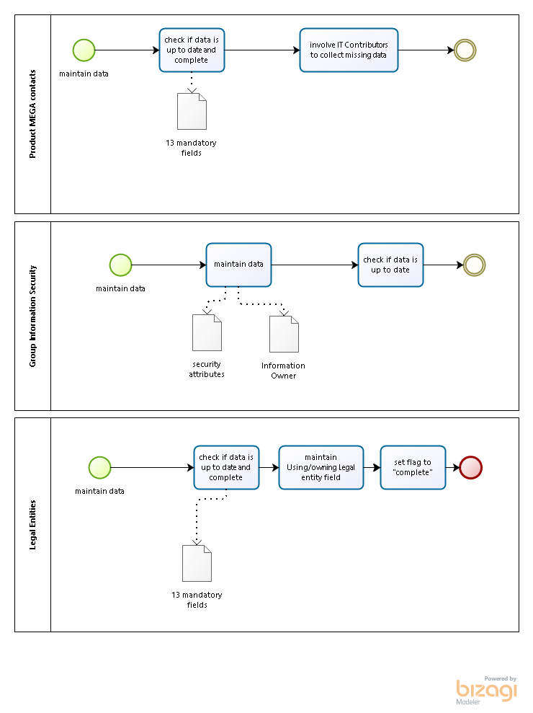

Figure 10: Maintenance process overview

## Ensure data quality of applications in MEGA

1. Report: On a quarterly basis the Corporate Tools unit creates a report regarding completeness of application data of the “mandatory” fields and sends a Reminder E-Mail to all product MEGA contacts; however, the products will take care of everything else. The reports will be sent at the beginning of an quarter.
2. Report: Furthermore, compliance reports regarding assigned applications to Using/Owning Legal Entities (confirm assignments) as well as information about completeness of application data will be sent on a quarterly basis to the banking-regulated Legal Entities. The reports will be sent mid of the quarter after the product MEGA contacts had the time to review the data.
3. Report: Quarterly an additional report (delta report) about new added and deleted applications as well as amended Using/Owning Legal Entities will be sent.

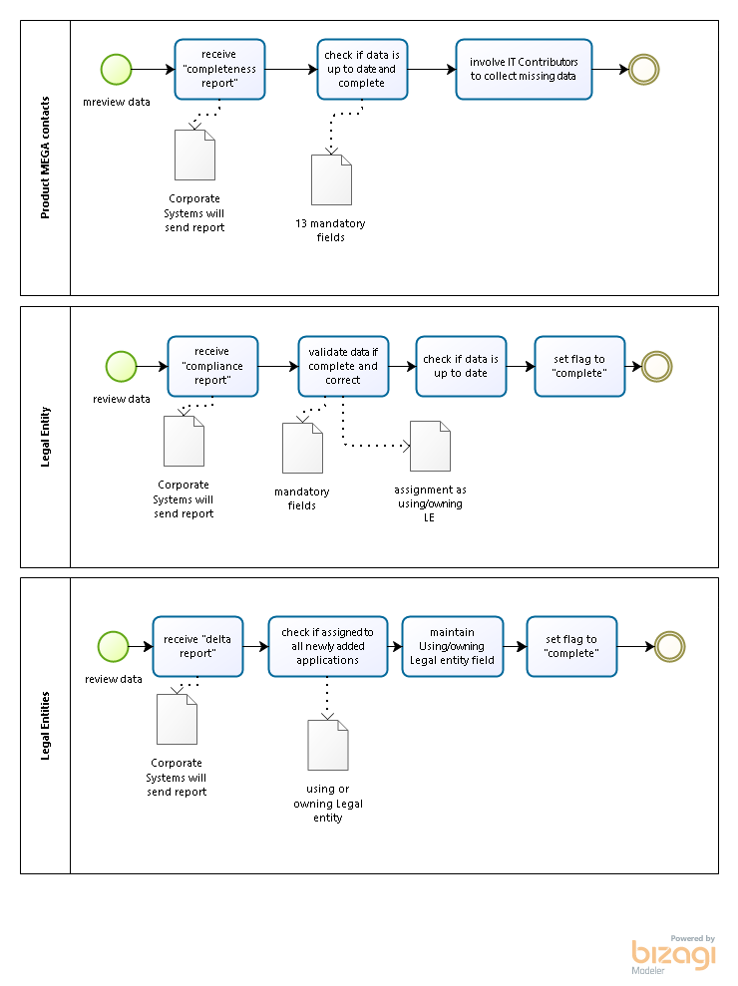

Figure 11**:** Review and contorl process overview

# Annex

## General definition of applications and technologies in Deutsche Boerse Group

Basic differentiation is between system software (operating system of any infrastructure), and (enterprise) application software.

Application Software can be differentiated into Business Applications, Desktop Applications, and Infrastructure / Platform Applications.

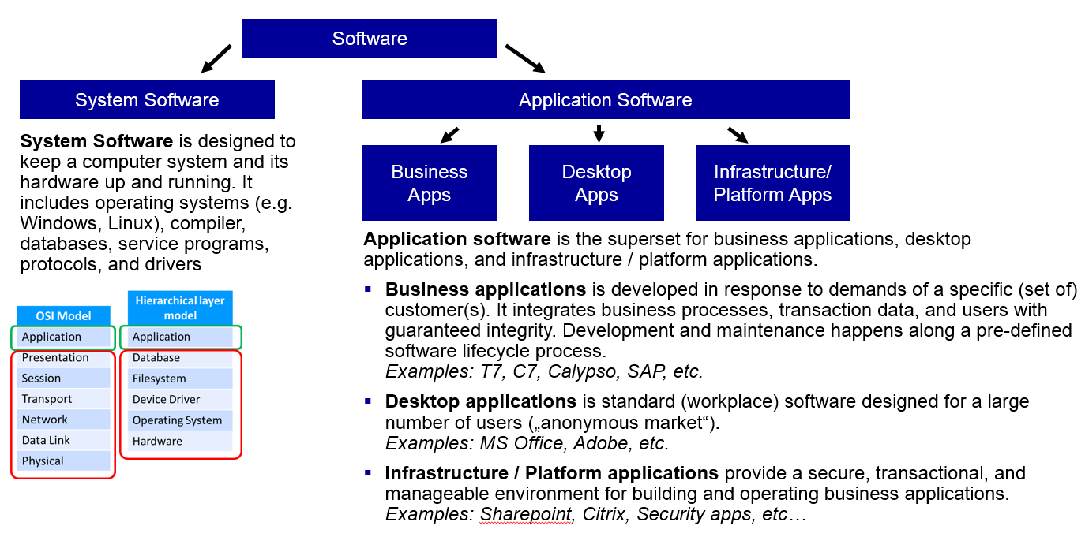

Figure 12**:** definition of an application within MEGA (as of 25.02.2018)

**Technology** is defined in a broad sense to address all logical and physical assets underpinning the implementation or execution of an application. This may include vendor or open source products, standards or internal technology assets. For example: Java.

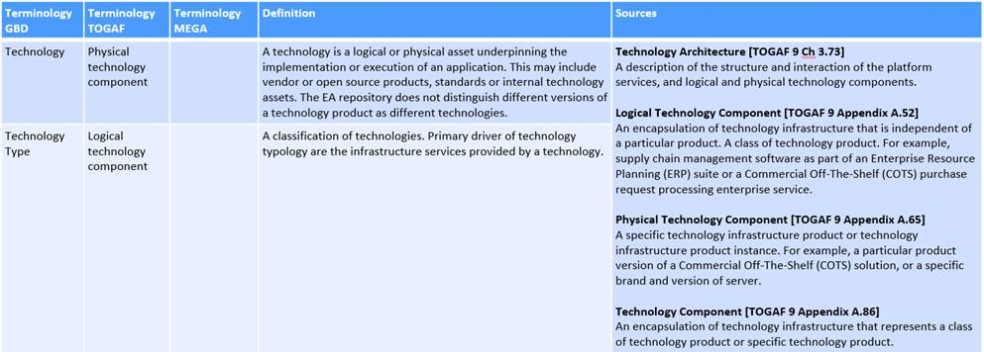

Figure 13: see ClearingModelling Guide slide no

## Overview of banking regulated Legal Entities

|  |  |  |  |
| --- | --- | --- | --- |
| **Legal Entity** | **Contact Person 1** | | |
| *\*banking-regulated LE* | User ID | Name | E-Mail |
| Clearstream Banking AG (Frankfurt) |  | Volker Riebesell | [volker.riebesell@clearstream.com](mailto:volker.riebesell@clearstream.com) |
| Clearstream Banking S.A. (Luxembourg) |  |  |  |
| Eurex Clearing AG |  | Thomas Wahl | [thomas.wahl@eurexclearing.com](mailto:thomas.wahl@eurexclearing.com) |
| Eurex Frankfurt AG |  | Wolfgang Eholzer | [wolfgang.eholzer@eurexchange.com](mailto:wolfgang.eholzer@eurexchange.com) |
| Lux CSD |  |  |  |

|  |  |  |  |
| --- | --- | --- | --- |
| **Legal Entity** | **Contact Person 2** | | |
| *\*banking-regulated LE* | User ID | Name | E-Mail |
| Clearstream Banking AG (Frankfurt) |  | Carsten Puls | [carsten.puls@clearstream.com](mailto:carsten.puls@clearstream.com) |
| Clearstream Banking S.A. (Luxembourg) |  | Tbd | tbd |
| Eurex Clearing AG |  | Arno Schamber | [arno.schamber@eurexclearing.com](mailto:arno.schamber@eurexclearing.com) |
| Eurex Frankfurt AG |  | Jens Hofmann | [jens.hofmann@eurexexchange.com](mailto:jens.hofmann@eurexexchange.com) |
| Lux CSD |  | Tbd | tbd |
| 360T |  | Simon Jones | [simon.jones@360t.com](mailto:simon.jones@360t.com) |

## Draft E-mail – inform Legal entities and Information Owner about newly added applications

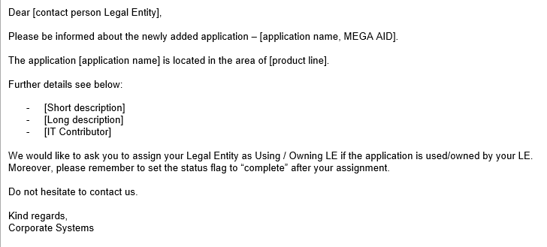

## Quick Guide on “how to view changes of application data”

With distributed “write access rights” you are able to view changes of application data via application history functionality on the MEGA GUI (see figure below).

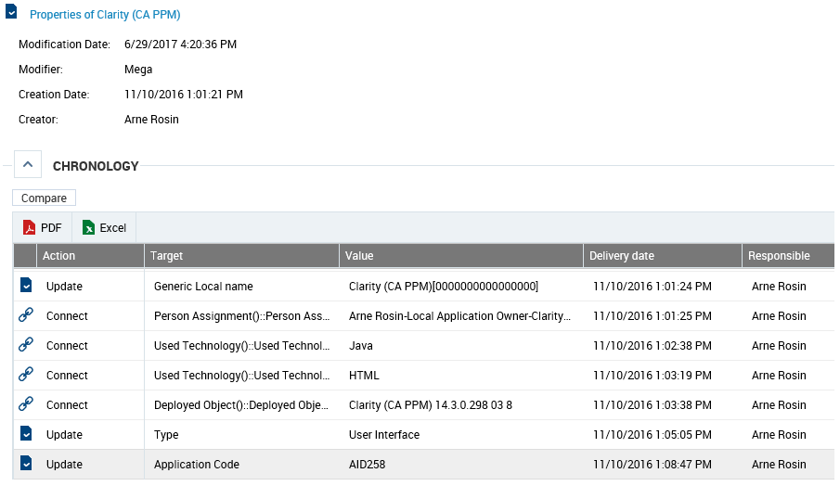

Figure 14: Screenshot of application history in the MEGA GUI

## Clearing Modelling Guide



Figure 15: Clearing Modelling Guide (as of 2017)

1. As of 29.08.2018 [↑](#footnote-ref-1)
2. See chapter 4.2 [↑](#footnote-ref-2)
3. See figure 3 MEGA product contacts [↑](#footnote-ref-3)
4. Definition of an application within MEGA see annex 4.1 [↑](#footnote-ref-6)
5. Contact details (User ID, Email address) of Legal Entities are directly stored in MEGA [↑](#footnote-ref-7)
6. Banking-regulated: Eurex Clearing AG, Clearstream Banking AG (FRA), Clearstream Banking S.A., Lux CSD and ECC [↑](#footnote-ref-8)
7. see <http://intranet.deutsche-boerse.de/INTRANET/departments/gis.nsf/0/5F585F612681D0F6C12576CE00537FA0/$file/Information%20Owners%20201706.pdf>) [↑](#footnote-ref-9)
8. Details see chapter 3.3.2 [↑](#footnote-ref-12)
9. For details on roles&rights please see chapter 3.2 and Authorization Concept [↑](#footnote-ref-13)